[root@localhost ~]# crontab -e

36 11 * * * sh /root/iptables.sh

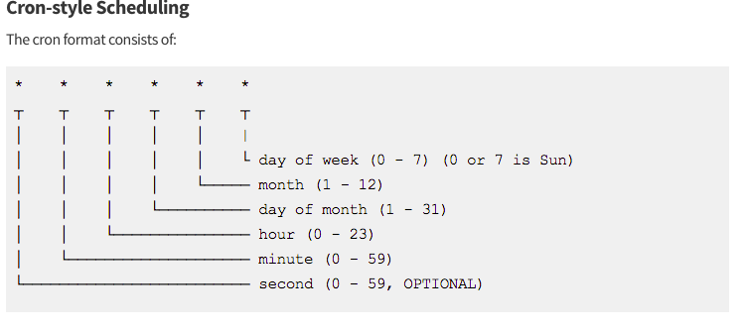

[root@localhost ~]# crontab -l

36 11 * * * sh /root/iptables.sh

**Check the log file**

[root@localhost ~]# tail -f /var/log/cron

Feb 4 11:36:01 localhost CROND[1608]: (root) CMD (sh /root/iptables.sh)